**Project Proposal**

Mobile Application Development

**Group Members:**

Ruman Munir (430873)

Kulveer Singh Dhillon (430776)

**Instructor:**

Mahbub Murshed

**GitHub Repository:**

https://github.com/rumanmunir1/ContactApp.git

**Project Title:**

Contact App

**Scope/Features of the app:**

As a user of smartphone, everybody in this generation has used Contact application in his life. We use it in our daily routine and use it to store the Contacts. Furthermore, for the modern Contact app that we will built will have the features like it will have picture section for each individual contact. The application will constitute of number of screens. The main screen would show the contacts stored by the user. Every contact will have its separate Name, Phone, Email, extra special note section and etc. Photo that will be assigned to contact will be uploaded or can be captured from the device. The most important feature of contact app is search that will also be added to the app by which the user can search for a specific contact instantly. During the development of the app, necessary APIs would also be added to meet the specific needs. Each contact will be saved in the database in order to carry out further operations. In order to save the time of the user, the edit contact feature will also be added by which the details of the specific contact will be updated and edited. The app user will also be able to delete a specific contact or made necessary changes to a contact. The complete application will be user friendly and will contain an aesthetic design. The necessary features and changes will be made during build and development of the project in the future.

**Wireframes:**

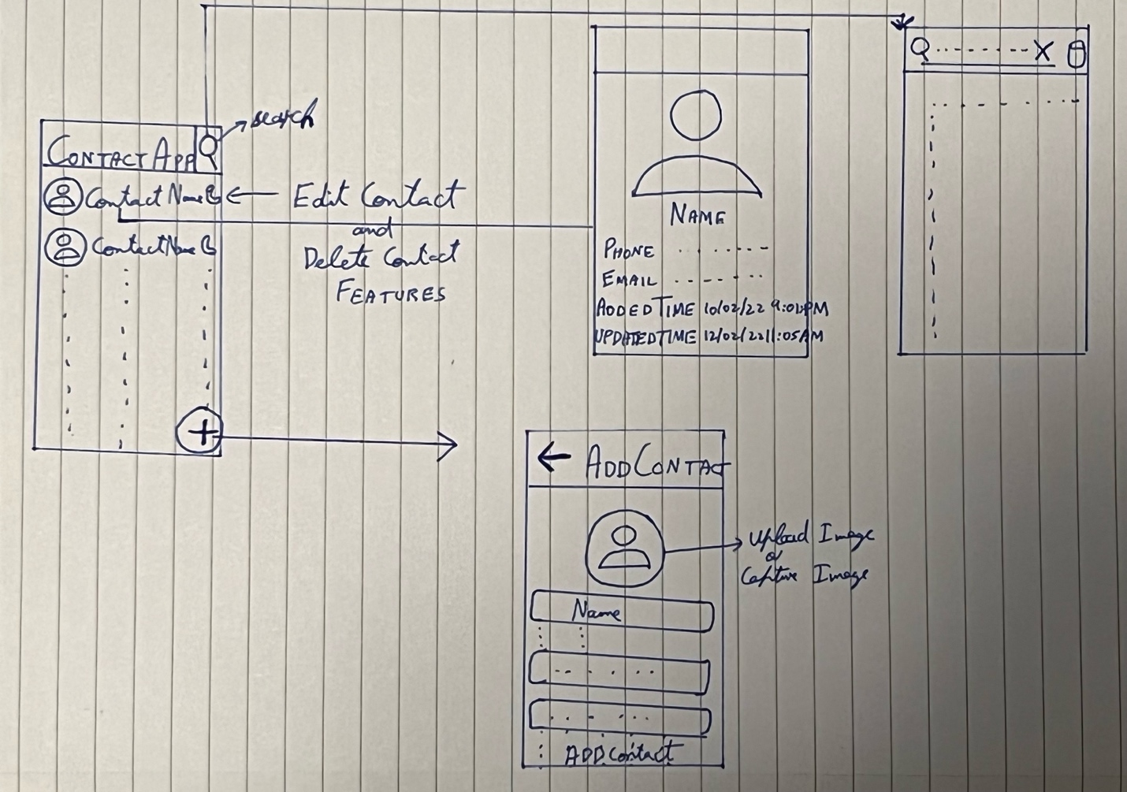

**GitHub Repository:**

https://github.com/rumanmunir1/ContactApp.git